**Project Name: Agriculture Management System**

**Project Member:**

**Anuradha Shivaji Sangale 210543181009**

**Varsha Bhaskar Pawar 210543181069**

**Vilas Nagoji Oulkar 210543181057**

**Akash Shivkumar Bhosale 210543181014**

**Abstract:**

Agriculture Management System is to help farmers by providing all kinds agriculture related information in the website. Agriculture Management System is farmer management website application which helps farmers to give best-practice farming processes. It helps farmers to improve their productivity and profitability. It enables farmers to sell their productions through online and farmers can purchase tools and seeds directly from seller. Farmers can view labours profile and they can hire labours.

The name Agriculture Management System indicates Intelligent Agriculture. Agriculture Management System is a model farmer management website application. This site helps the farmers to sell their agricultural produce online and suggests best -in-practice farming processes. Hence, providing a wider market and helping them to not restrict themselves to the local market. This enables wholesalers and retailers to expand their business.

**Implementation Technologies:**

1. **Spring Framework:**

Spring Framework is a Java platform that provides comprehensive infrastructure support for developing Java applications. Spring handles the infrastructure so you can focus on your application.

Spring enables you to build applications from “plain old Java objects” (POJOs) and to apply enterprise services non-invasively to POJOs. This capability applies to the Java SE programming model and to full and partial Java EE.

**1.1 Features of Spring Framework:**

**1. Lightweight**

Spring is modular lightweight framework which allows you to selectively use any of its modules on the top of Spring Core.

**2. Inversion of Control (IOC)**

This is another top feature of Spring framework where application dependencies are satisfied by the framework itself. Framework creates the object in runtime and satisfies application dependencies.

**3. Aspect Oriented Programming (AOP)**

Aspect Oriented Programming (AOP) is very popular in programming world and in Spring it is well implemented. Developer can use Aspect Oriented Programming (AOP feature of Spring to develop application in which business logic is separated from system services.

**4. Container**

Spring provides their own container for managing the bean lifecycle.

**5. MVC Framework**

Spring MVC Framework is used for developing MVC based web applications.

**6. Transaction Management**

Spring framework provides generic Transaction Management layer which can be used with or without J2EE(JEE) environment.

**7. JDBC Exception Handling**

Spring provides their own abstraction of JDBC exception which further simplifies the exception handling in program.

**1.2 Advantages of Spring Framework:**

**1. Solving difficulties of Enterprise application development**

Spring is solving the difficulties of development of complex applications, it provides Spring Core, Spring IOC and Spring AOP for integrating various components of business applications.

**2. Support Enterprise application development through POJOs**

Spring supports development of Enterprise application development using the POJO classes which removes the need of importing heavy Enterprise container during development. This makes application testing much easier.

**3. Easy integration other frameworks**

Spring designed to be used with all other frameworks of Java, you can use ORM, Struts, Hibernate and other frameworks of Java together. Spring framework do not impose any restriction on the frameworks to be used together.

**4. Application Testing**

Spring Container can be used to develop and run test cases outside enterprise container which makes testing much easier.

**5. Modularity**

Spring framework is modular framework and it comes with many modules such as Spring MVC, Spring ORM, Spring JDBC, Spring Transactions etc. which can used as per application requirement in modular fashion.

**6. Spring Transaction Management**

Spring Transaction Management interface is very flexible it can configure to use local transactions in small application which can be scaled to JTA for global transactions.

1. **The JDBC Template**

The central class of the Spring JDBC abstraction framework is the **JdbcTemplate** class that includes the most common logic in using the JDBC API to access data, such as handling the creation of connection, statement creation, statement execution, and release of resource. The**Jdbc-Template**class can be found in the **org.springframework.jdbc.core**package.

The **JdbcTemplate** class instances are thread-safe once configured. A single **JdbcTemplate** can be configured and injected into multiple DAOs.

We can use the **JdbcTemplate** to execute the different types of SQL statements. **Data Manipulation Language** (**DML**) is used for inserting, retrieving, updating, and deleting the data in the database such as **SELECT**, **INSERT**, or **UPDATE** statements

**2.1** **MySQL**

MySQL, the most popular Open Source SQL database management system, is developed, distributed, and supported by Oracle Corporation.

**Features of MySQL:**

* **MySQL is a database management system.**

A database is a structured collection of data. It may be anything from a simple shopping list to a picture gallery or the vast amounts of information in a corporate network. To add, access, and process data stored in a computer database, you need a database management system such as MySQL Server. Since computers are very good at handling large amounts of data, database management systems play a central role in computing, as standalone utilities, or as parts of other applications.

* **MySQL databases are relational.**

A relational database stores data in separate tables rather than putting all the data in one big storeroom. The database structures are organized into physical files optimized for speed. The logical model, with objects such as databases, tables, views, rows, and columns, offers a flexible programming environment.

* **MySQL software is Open Source.**

Open Source means that it is possible for anyone to use and modify the software. Anybody can download the MySQL software from the Internet and use it without paying anything.

* **The MySQL Database Server is very fast, reliable, scalable, and easy to use.**

MySQL Server was originally developed to handle large databases much faster than existing solutions and has been successfully used in highly demanding production environments for several years. Although under constant development, MySQL Server today offers a rich and useful set of functions. Its connectivity, speed, and security make MySQL Server highly suited for accessing databases on the Internet.

* **MySQL Server works in client/server or embedded systems.**

The MySQL Database Software is a client/server system that consists of a multithreaded SQL server that supports different back ends, several different client programs and libraries, administrative tools, and a wide range of application programming interfaces (APIs).

1. **Hardware, Software Requirements (Minimum) and Language Used:**

**Hardware:**

1. Operating System: Windows 7/8/8.1/10

2. Processor: Intel Core i3

3. RAM: 1GB or more

4. ROM: 500MB or more

5. Data Connection 200 kbps

**Software:**

1. Apache Server 8.5
2. MySQL 5.7 with Workbench 8.0
3. Browser: Google chrome, Mozilla Firefox etc

**Languages Used:**

1. Front end: HTML, CSS, Bootstrap, Thymeleaf
2. Backend: Java, Javascript, JDBC Driver
3. Database: MySQL Server
4. **ER Diagram:**

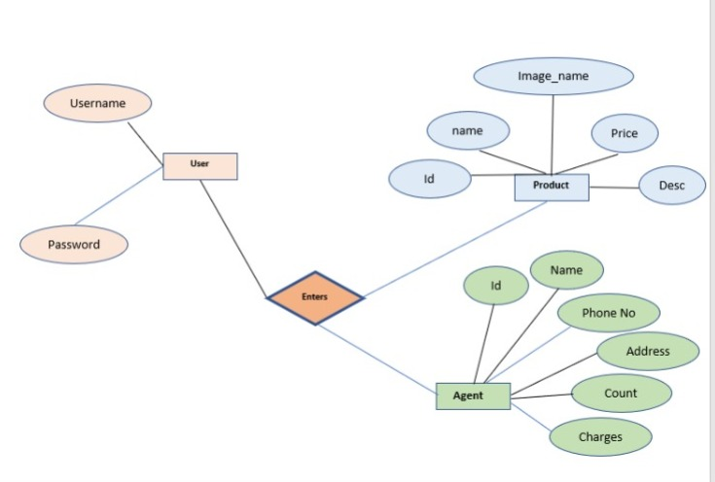

Figure 1: ER Diagram 1

1. **Table Structures:**
2. **Table Name :Users**

**Column name Type**

Id int NO PRI auto_increment

Email varchar(255) YES

First_Name varchar(255) YES

Last_Name varchar(255) YES

Password varchar(255) YES

1. **Table Name : Product**

**Column name Type**

Id bigint NO PRI auto_increment

Description varchar(255) YES

Image_Name varchar(255) YES

Name Varchar(255) YES

Price Double YES

Category_id int YES MUL

1. **Table Name : Agent**

**Column name Type**

Id int NO PRI auto_increment

City varchar(255) YES

State varchar(255) YES

Contact bigint YES

Labor_count int YES

Name varchar(255) YES

Rate Double YES

1. **UML Diagrams:**

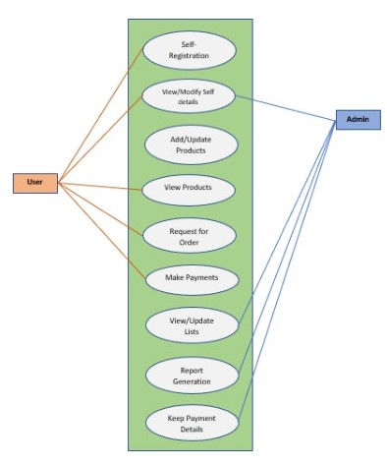

Figure 2: Use Case

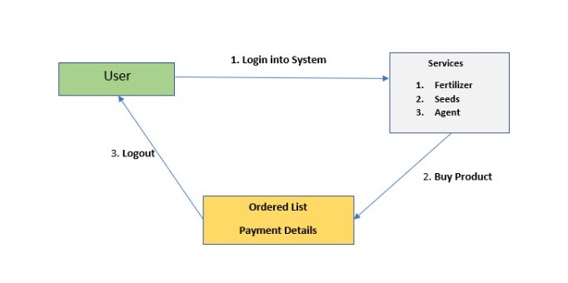

Figure 3: Collaboration Diagram

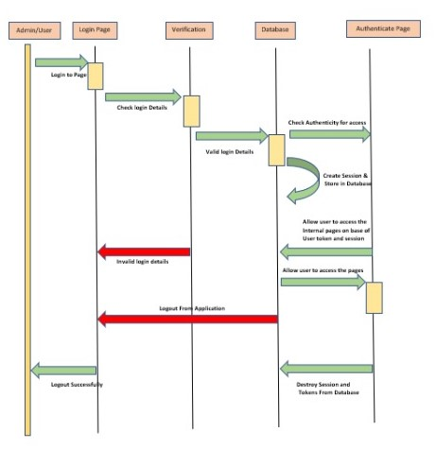

Figure 4: Sequence Diagram

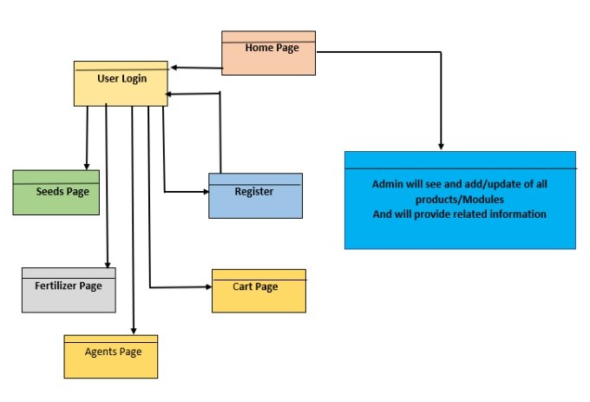

Figure 5: Component Diagram

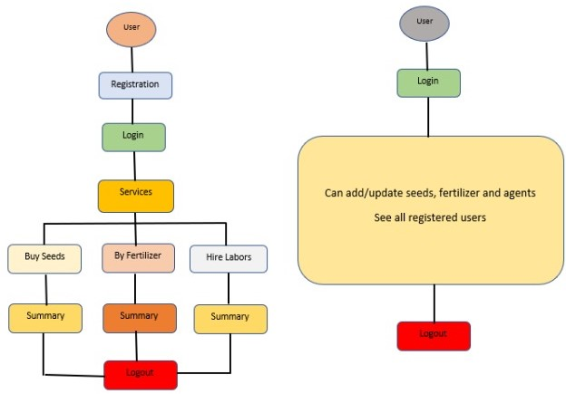

Figure 6: State Diagram

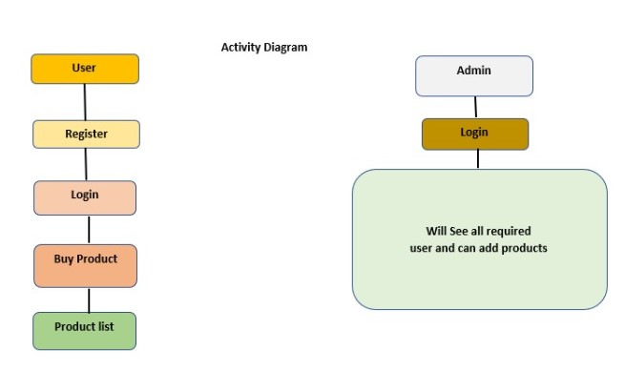

Figure 7: Activity Diagram

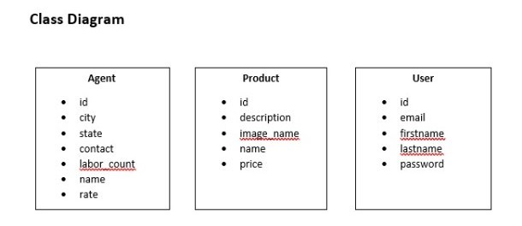 Figure 8: Class Diagram

1. **End to End Flow of Application:**

**User:**

* 1. User will login to the portal or will have to register if he is not a registered user.
  2. After registration User will login and Dashboard page will be displayed, Dashboard contains Home page, Seeds page, Fertilizer page, Agent page and Cart.
  3. From that page User can click either on the ‘**Seeds page to buy seeds’** or ‘**Fertilizer page to Buy Any fertilizer’** or ‘**Agent Page to Hire Labors’.**
  4. In the Labor page the User can pick labors segregated by the cities and states. He can hire labors which are closer to his location.
  5. A ‘**summary report’** will be displayed on the Website showing all the ordered product list details in case of user.

**Admin:**

1. Admin will login as Admin from the ‘**Admin login**’ page and will be able to see registered user’s list.
2. Admin Can able to Add and Update products i.e., Seeds and Fertilizers.
3. It is the job of Admin to assign appropriate rate for the products.
4. **Future Scope of Project:**

Agriculture management system can be implemented by using satellites. With help of satellite communication user can observe the climatic conditions of the farm even by sitting at home.

**Thank You!**